 |   MC-7180 | 
  DIAGNOSTIC REPORT
PATIENT NAME : SHEETAL BHURKE | REF. DOCTOR : DR. GANESH BHAGWAT

CODE/NAME & ADDRESS : CS00008567  AGILUS DR PHADKE- PSC CAMLIN HOME  210,RAMBAUG BLDG, GROUND FLR, L.J.ROAD, MAHIMMUMBAI  MUMBAI 400016  7304496384 | ACCESSION NO : 5047ZA038019 PATIENT ID : SHEEF02076927 CLIENT PATIENT ID: SHEEF02076927 ABHA NO : | AGE/SEX :56 Years Female  DRAWN :23/01/2026 10:04:03  RECEIVED : 23/01/2026 10:52:37  REPORTED :23/01/2026 13:47:12

Test Report Status | Final | Results | Biological Reference Interval | Units
HAEMATOLOGY - CBC
CBC-5, EDTA WHOLE BLOOD
BLOOD COUNTS, EDTA WHOLE BLOOD
HEMOGLOBIN (HB) | 9.3 Low | 12.0 - 15.0 | g/dL
METHOD : SLS METHOD
RED BLOOD CELL (RBC) COUNT | 4.01 | 3.80 - 4.80 | mil/µL
METHOD : ELECTRICAL IMPEDANCE
WHITE BLOOD CELL (WBC) COUNT | 6.12 | 4 - 10 | thou/µL
METHOD : FLOW CYTOMETRY
PLATELET COUNT | 426 High | 150 - 410 | thou/µL
METHOD : ELECTRICAL IMPEDANCE
RBC AND PLATELET INDICES
HEMATOCRIT (PCV) | 33.3 Low | 36.0 - 46.0 | %
METHOD : PULSE HEIGHT DETECTION
MEAN CORPUSCULAR VOLUME (MCV) | 83.0 | 83.0 - 101.0 | fL
METHOD : CALCULATED
MEAN CORPUSCULAR HEMOGLOBIN (MCH) | 23.2 Low | 27.0 - 32.0 | pg
METHOD : CALCULATED
MEAN CORPUSCULAR HEMOGLOBIN | 27.9 Low | 31.5 - 34.5 | g/dL
CONCENTRATION(MCHC)
METHOD : CALCULATED
RED CELL DISTRIBUTION WIDTH (RDW) | 15.2 High | 11.6 - 14.0 | %
METHOD : CALCULATED
MEAN PLATELET VOLUME (MPV) | 9.3 | 6.80 - 10.90 | fL
METHOD : CALCULATED
WBC DIFFERENTIAL COUNT
NEUTROPHILS | 60 | 40 - 80 | %
METHOD : FLOW CYTOMETRY
LYMPHOCYTES | 29 | 20 - 40 | %
METHOD : FLOW CYTOMETRY
MONOCYTES | 7 | 2 - 10 | %
METHOD : FLOW CYTOMETRY
 Page 1 Of 4
DR. ALVIN ALVA (MD)
CONSULTANT PATHOLOGIST
View Details | View Report
PERFORMED AT :
Agilus Pathlabs Private Limited
Mahalakshmi Engineering Estate, Mahim West Mumbai, 400028 | ULR No.504700008483598-5047
Maharashtra, INDIA
Tel : 9819938916, Fax : CIN - U85I95DL1999PTC217659

 | MC-7180
  DIAGNOSTIC REPORT
PATIENT NAME : SHEETAL BHURKE | REF. DOCTOR : DR. GANESH BHAGWAT

CODE/NAME & ADDRESS : CS00008567  AGILUS DR PHADKE- PSC CAMLIN HOME  210,RAMBAUG BLDG, GROUND FLR, L.J.ROAD, MAHIMMUMBAI  MUMBAI 400016  7304496384 | ACCESSION NO : 5047ZA038019 PATIENT ID : SHEEF02076927 CLIENT PATIENT ID: SHEEF02076927 ABHA NO : | AGE/SEX :56 Years Female  DRAWN :23/01/2026 10:04:03  RECEIVED : 23/01/2026 10:52:37  REPORTED :23/01/2026 13:47:12

Test Report Status | Final | 3 | Results | Biological Reference Interval | % | Units
EOSINOPHILS | Final | 3 | Results | 1 - 6 | % | Units
METHOD : FLOW CYTOMETRY
BASOPHILS | 1 | < 1 - 2 | %
METHOD : FLOW CYTOMETRY
ABSOLUTE NEUTROPHIL COUNT | 3.70 | 2 - 7 | thou/µL
METHOD : CALCULATED
ABSOLUTE LYMPHOCYTE COUNT | 1.76 | 1 - 3 | thou/µL
METHOD : CALCULATED
ABSOLUTE MONOCYTE COUNT | 0.45 | 0.2 - 1 | thou/µL
METHOD : CALCULATED
ABSOLUTE EOSINOPHIL COUNT | 0.18 | 0.02 - 0.50 | thou/µL
METHOD : CALCULATED
ABSOLUTE BASOPHIL COUNT | 0.03 | 0 - 0.1 | thou/µL
METHOD : CALCULATED
MORPHOLOGY (MICROSCOPY)
RBC HYPOCHROMIA
Interpretation(s)
RBC AND PLATELET INDICES-Mentzer index (MCV/RBC) is an automated cell-counter based calculated screen tool to differentiate cases of Iron deficiency anaemia(>13) from Beta thalassaemia trait (<13) in patients with microcytic anaemia. This needs to be interpreted in line with clinical correlation and suspicion. Estimation of HbA2 remains the gold standard for diagnosing a case of beta thalassaemia trait.
WBC DIFFERENTIAL COUNT-The optimal threshold of 3.3 for NLR showed a prognostic possibility of clinical symptoms to change from mild to severe in COVID positive patients. When age = 49.5 years old and NLR = 3.3, 46.1% COVID-19 patients with mild disease might become severe. By contrast, when age < 49.5 years old and NLR < 3.3, COVID-19 patients tend to show mild disease. (Reference to - The diagnostic and predictive role of NLR, d-NLR and PLR in COVID-19 patients A.-P. Yang, et al.
International Immunopharmacology 84 (2020) 106504
This ratio element is a calculated parameter and out of NABL scope.
Page 2 Of 4
DR. ALVIN ALVA (MD)
CONSULTANT PATHOLOGIST
View Details | View Report
PERFORMED AT :
Agilus Pathlabs Private Limited
Mahalakshmi Engineering Estate, Mahim West Mumbai, 400028 | ULR No.504700008483598-5047
Maharashtra, INDIA
Tel : 9819938916, Fax : CIN - U85I95DL1999PTC217659

 | MC-7180
  DIAGNOSTIC REPORT
PATIENT NAME : SHEETAL BHURKE | REF. DOCTOR : DR. GANESH BHAGWAT

CODE/NAME & ADDRESS : CS00008567  AGILUS DR PHADKE- PSC CAMLIN HOME  210,RAMBAUG BLDG, GROUND FLR, L.J.ROAD, MAHIMMUMBAI  MUMBAI 400016  7304496384 | ACCESSION NO : 5047ZA038019 PATIENT ID : SHEEF02076927 CLIENT PATIENT ID: SHEEF02076927 ABHA NO : | AGE/SEX :56 Years Female  DRAWN :23/01/2026 10:04:03  RECEIVED : 23/01/2026 10:52:37  REPORTED :23/01/2026 13:47:12

Test Report Status | Final | Results | Biological Reference Interval | Units
ENDOCRINOLOGY
THYROID PANEL II (FT3,FT4,TSH) SERUM
FREE TRIIODOTHYRONINE (FT3) | 2.39 | 1.58 - 3.91 | pg/mL
METHOD : CMIA
FREE THYROXINE (FT4) | 1.19 | 0.70 - 1.48 | ng/dL
METHOD : CMIA
TSH (ULTRASENSITIVE) | 2.150 | Euthyroid : 0.35 - 4.94 | µIU/mL
Hypothyroid : > 4.94
Hyperthyroid : < 0.35
Pregnant Women (As per
American Thyroid Association)
1st Trimester 0.100 - 2.500
2nd Trimester 0.200 - 3.000
3rd Trimester 0.300 - 3.000
Please note change in reference
range.
METHOD : CMIA
Interpretation(s)
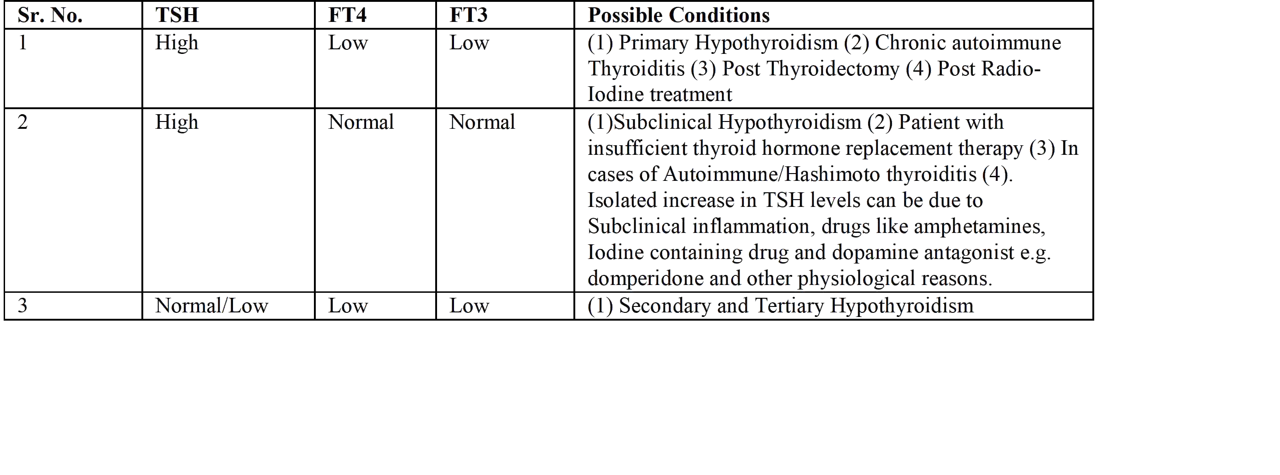
 |  |  | Page 3 Of 4
Dr. Geetha Chandrashekhar, MD | DR. SONAL PRIYA | DR. NIKHIL MAJETHIA | Page 3 Of 4
Consultant Pathologist | CONSULTANT PATHOLOGIST | Deputy Lab-Head Consultant | Page 3 Of 4
pathologist
View Details | View Report
PERFORMED AT :
Agilus Pathlabs Private Limited
Mahalakshmi Engineering Estate, Mahim West Mumbai, 400028 | ULR No.504700008483598-5047
Maharashtra, INDIA
Tel : 9819938916, Fax : CIN - U85I95DL1999PTC217659

 | MC-7180
  DIAGNOSTIC REPORT
PATIENT NAME : SHEETAL BHURKE | REF. DOCTOR : DR. GANESH BHAGWAT

CODE/NAME & ADDRESS : CS00008567  AGILUS DR PHADKE- PSC CAMLIN HOME  210,RAMBAUG BLDG, GROUND FLR, L.J.ROAD, MAHIMMUMBAI  MUMBAI 400016  7304496384 | ACCESSION NO : 5047ZA038019 PATIENT ID : SHEEF02076927 CLIENT PATIENT ID: SHEEF02076927 ABHA NO : | AGE/SEX :56 Years Female  DRAWN :23/01/2026 10:04:03  RECEIVED : 23/01/2026 10:52:37  REPORTED :23/01/2026 13:47:12

Test Report Status | Final | Results | Biological Reference Interval | Units
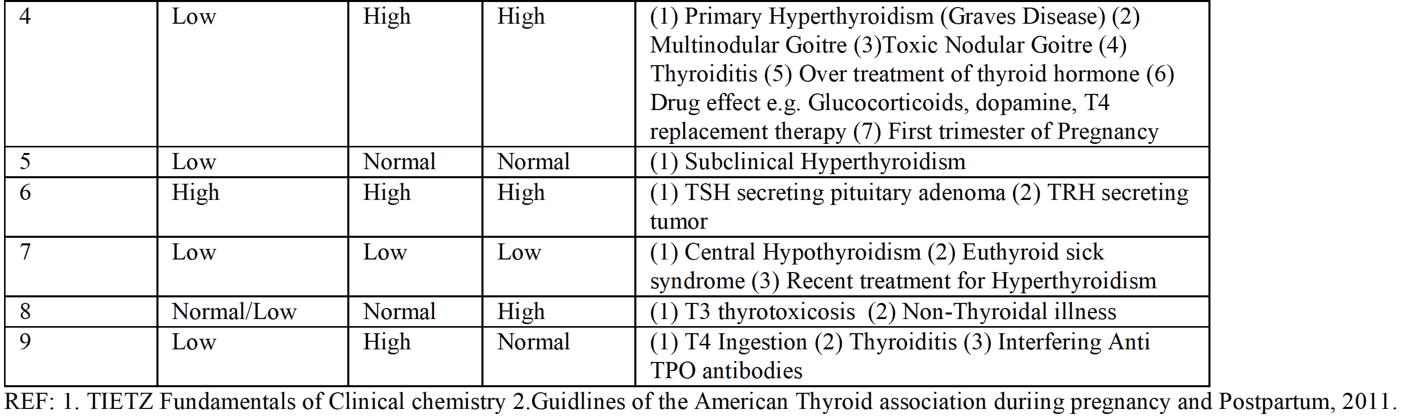
**End Of Report**
Please visit www.agilusdiagnostics.com for related Test Information for this accession
CONDITIONS OF LABORATORY TESTING & REPORTING
1. It is presumed that the test sample belongs to the patient 5. AGILUS Diagnostics confirms that all tests have been named or identified in the test requisition form. performed or assayed with highest quality standards, clinical 2. All tests are performed and reported as per the safety & technical integrity.
turnaround time stated in the AGILUS Directory of Services. 6. Laboratory results should not be interpreted in isolation; 3. Result delays could occur due to unforeseen it must be correlated with clinical information and be circumstances such as non-availability of kits / equipment interpreted by registered medical practitioners only to breakdown / natural calamities / technical downtime or any determine final diagnosis.
other unforeseen event. 7. Test results may vary based on time of collection, 4. A requested test might not be performed if: physiological condition of the patient, current medication or i. Specimen received is insufficient or inappropriate nutritional and dietary changes. Please consult your doctor ii. Specimen quality is unsatisfactory or call us for any clarification.
iii. Incorrect specimen type 8. Test results cannot be used for Medico legal purposes.
iv. Discrepancy between identification on specimen 9. In case of queries please call customer care container label and test requisition form (91115 91115) within 48 hours of the report.
Agilus Diagnostics Ltd
Fortis Hospital, Sector 62, Phase VIII,
Mohali 160062

 |  |  | Page 4 Of 4
Dr. Geetha Chandrashekhar, MD | DR. SONAL PRIYA | DR. NIKHIL MAJETHIA | Page 4 Of 4
Consultant Pathologist | CONSULTANT PATHOLOGIST | Deputy Lab-Head Consultant | Page 4 Of 4
pathologist
View Details | View Report
PERFORMED AT :
Agilus Pathlabs Private Limited
Mahalakshmi Engineering Estate, Mahim West Mumbai, 400028 | ULR No.504700008483598-5047
Maharashtra, INDIA
Tel : 9819938916, Fax : CIN - U85I95DL1999PTC217659

